User will open the app

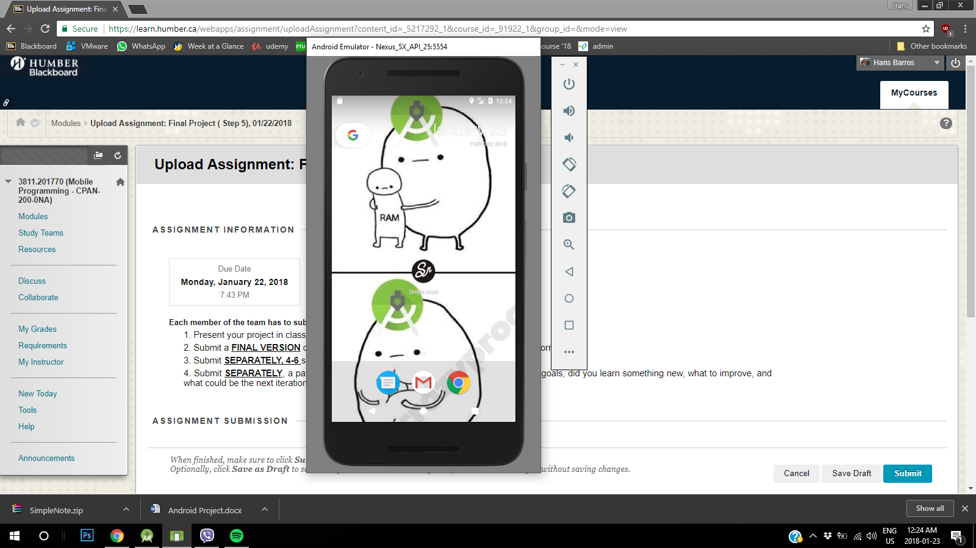

User will see the notes already taken and press the new note button

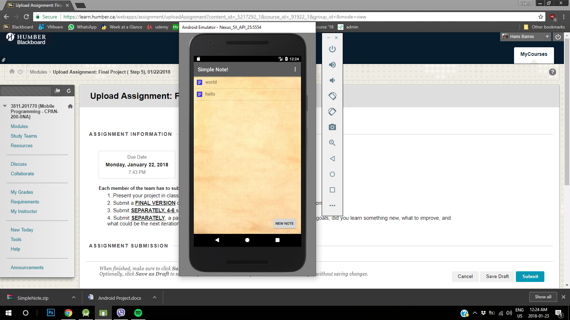

By pressing the new note button you can create the note then press the back button at the top right

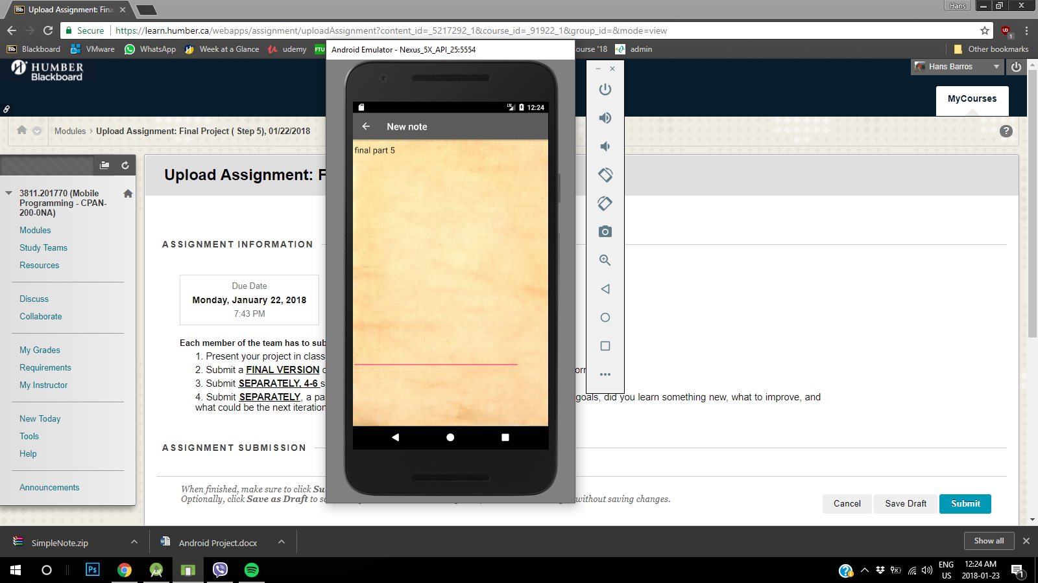

This will bring us to the menu again

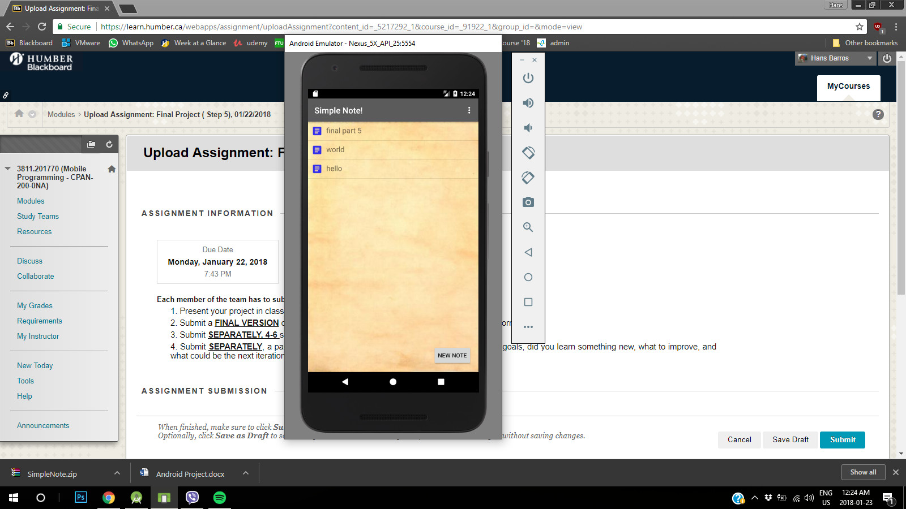

**Pressing the new note again, it will show the trash button on the right side of the page**

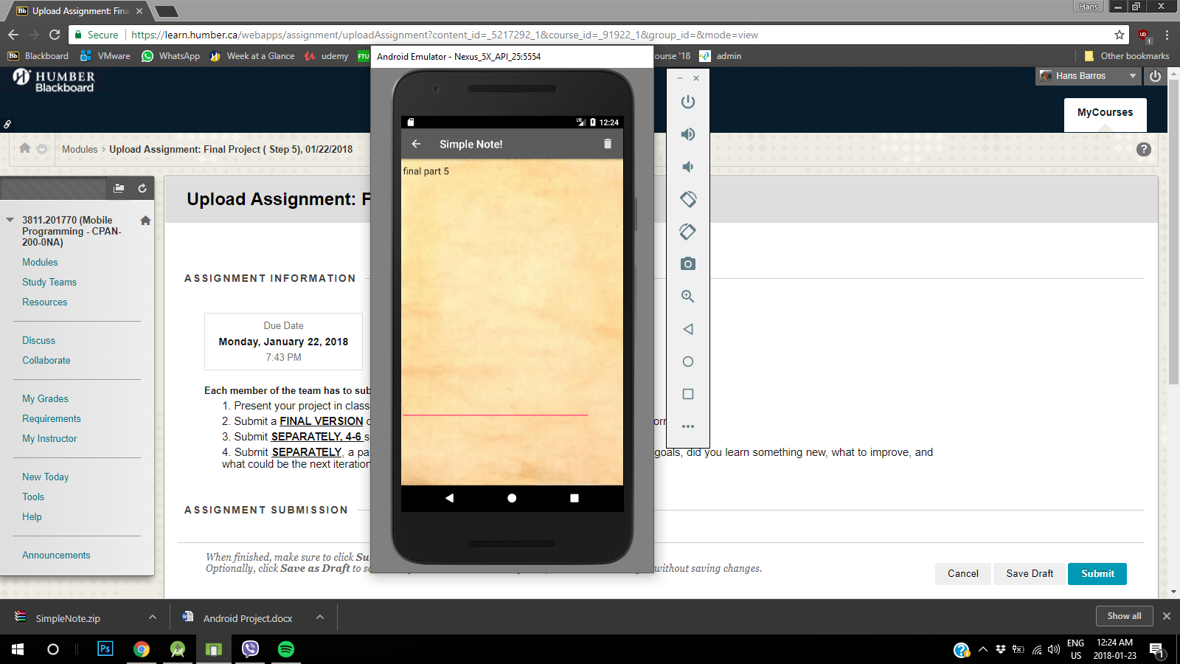

**By pressing the trash it will delete the new note and bring the user to the menu**

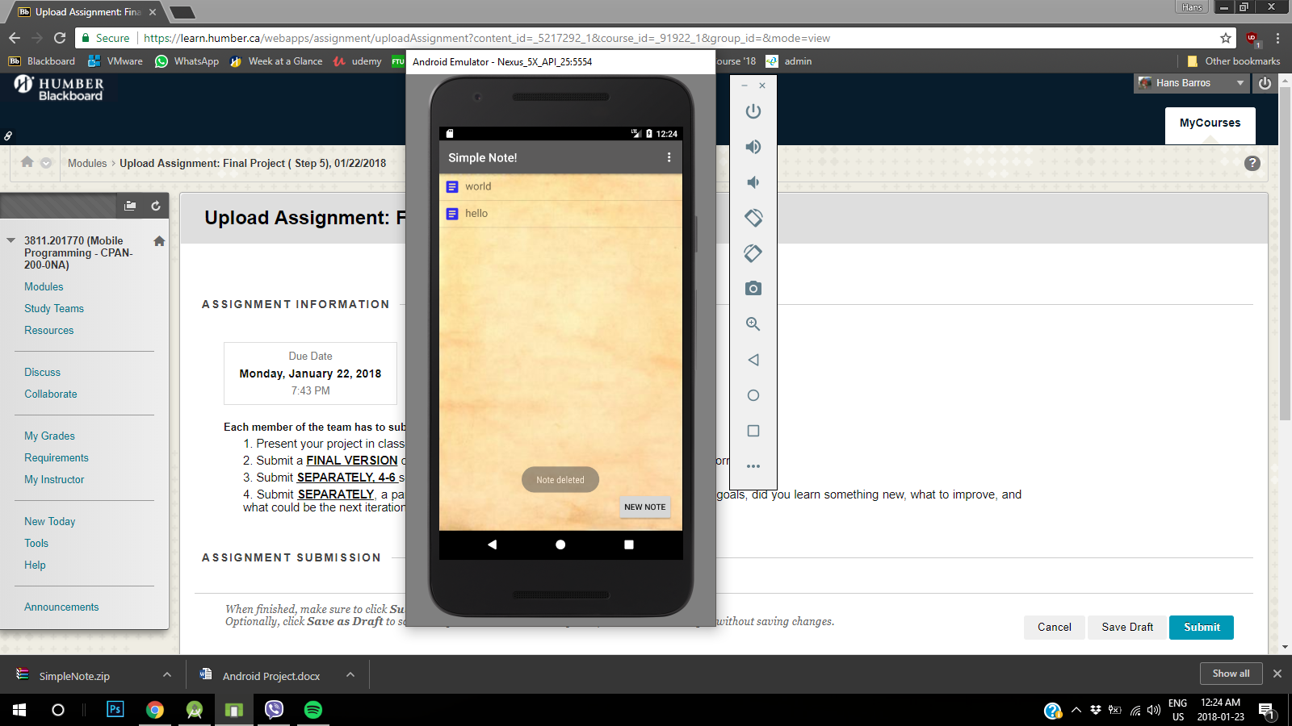

If we press the top right option we can press delete all notes for an easier time to the user

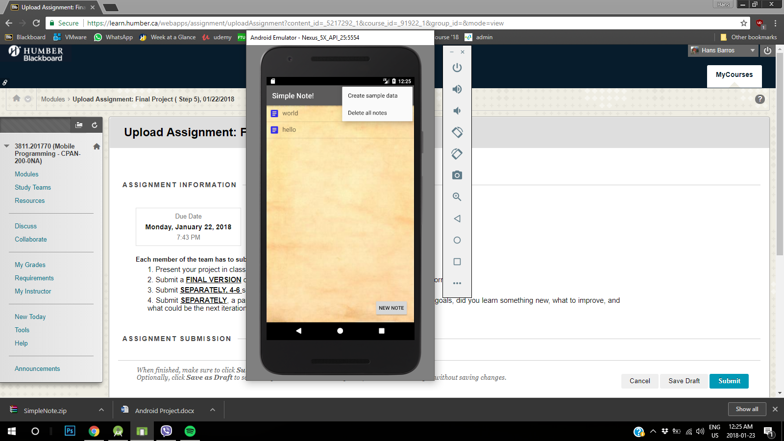

A toast will show saying all notes deleted and no notes will be shown

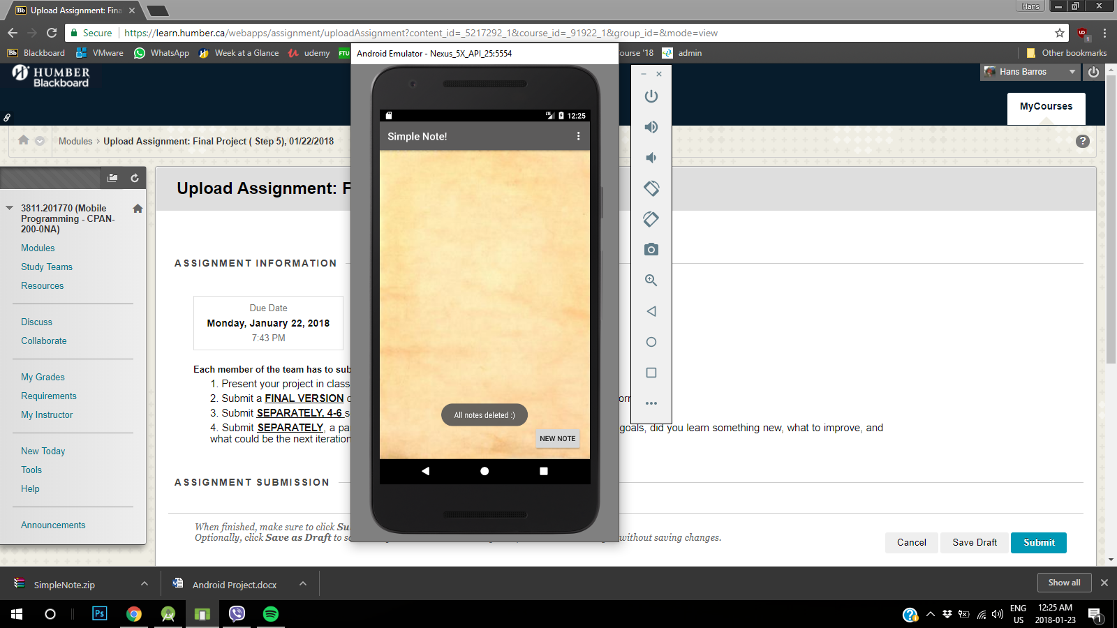

The user will press the option again and it will show help button

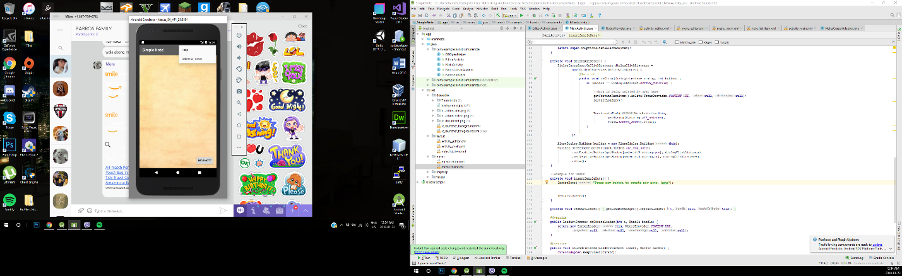

By pressing help button it will show instructions on how to achieve a new note

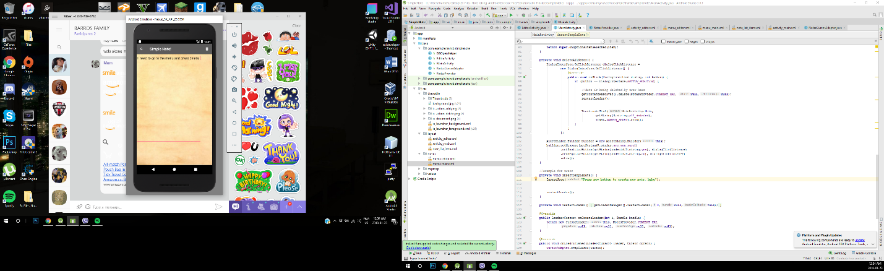

Conclusion to project: Yes, Amrit and I have achieved our goal at making our note application. We learned that how to use SQLite in android applications. It allowed me to put SQL knowledge together with Java application knowledge. Also playing with CRUD methods and retrieving data from the main activity with the cursor load. We have realized that the simplest app can be at times challenging to make so appreciate what the smallest things are on your device. We mostly need to improve on is having a better inspection on the code, first time running the application is would crash every time but we found the simplest spelling mistake and it would perfectly run again. The next iteration step is to either deploy it to the app store or make more options for the user to achieve a better note taking.